Tic Tac Toe Game
Aim
To implement the Tic Tac Toe game using Python.
Objective
- To create a two-player Tic Tac Toe game.
- To determine the winner or draw.
- To understand game logic implementation.
Algorithm
- Create a 3×3 board.
- Display the board.
- Player X enters a position.
- Update the board.
- Check for a winning condition.
- If no winner, switch to Player O.
- Repeat until a player wins or the board is full.
- Display the result.
Flow Chart
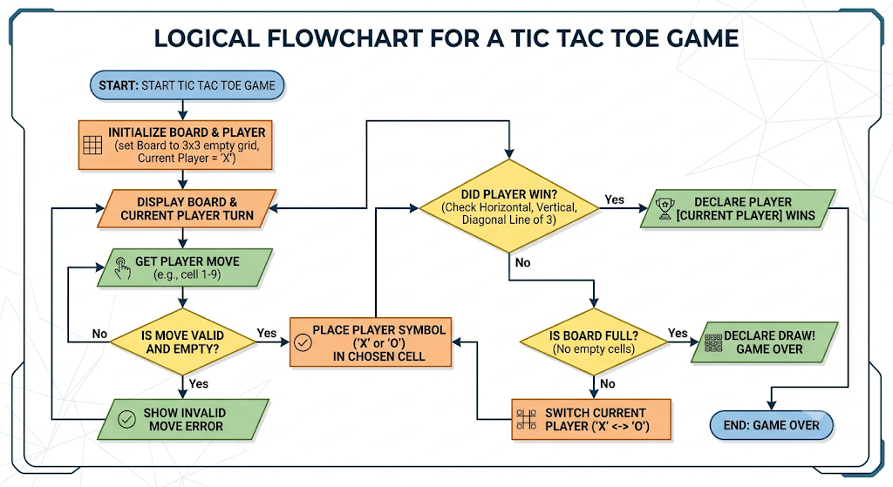

PYTHON CODE
board = [' ' for _ in range(9)]

def print_board():
print()
print(board[0], '|', board[1], '|', board[2])
print('--+---+--')
print(board[3], '|', board[4], '|', board[5])
print('--+---+--')
print(board[6], '|', board[7], '|', board[8])
print()

def check_winner(player):
wins = [
(0,1,2),(3,4,5),(6,7,8),
(0,3,6),(1,4,7),(2,5,8),
(0,4,8),(2,4,6)
]

for a,b,c in wins:
if board[a] == board[b] == board[c] == player:
return True
return False

player = 'X'

for turn in range(9):
print_board()

pos = int(input(f"Player {player}, enter position (1-9): ")) - 1

if board[pos] == ' ':
board[pos] = player

if check_winner(player):
print_board()
print(f"Player {player} Wins!")
break

player = 'O' if player == 'X' else 'X'
else:
print("Position already occupied.")
else:
print_board()
print("It's a Draw!")

RESULT
